

**KOLEJ PROFESIONAL MARA BERANANG**

**DIPLOMA IN COMPUTER SCIENCE**

|  |  |  |
| --- | --- | --- |
| **COURSE NAME** | **:** | **WEBSITE APPLICATION DEVELOPMENT** |
| **COURSE CODE** | **:** | **CSC2173** |
| **ACADEMIC SESSION** | **:** | **SESSION 1 2023/2024** |
| **TYPE OF ASSESSMENT** | **:** | **PRACTICAL TEST 1** |
| **DURATION** | **:** | **1.5 HOURS** |

**CLO 2: BUILD DYNAMIC WEBSITE BASED ON WEB FRAMEWORK.**

**INSTRUCTION TO CANDIDATES:**

1. Time allowed is **1.5 HOURS.**
2. Execute all tasks.
3. Submit Django project folder (compressed/zip) and a document containing the screenshot in MS Teams.

|  |  |
| --- | --- |
| **Section / Question No.** | **Marks** |
| **Part A** | **/3.5** |
| **Part B** | **/12.5** |
| **Part C** | **/24** |
| **Total** | **/40** |

|  |  |
| --- | --- |
| **Personal Details** | |
| **Name** |  |
| **I/D Number** |  |
| **Class** | **DCS 4 [A]** |
| **Lecturer** | **PUAN NURHANNANIE** |

### Overview

Tables shown below are part of Car_Rental database.

CLIENT

|  |  |  |  |
| --- | --- | --- | --- |
| ClientId(PK) | Clienname | clientphone | gender |
| C1 | Ramesh | 0128889999 | M |
| C2 | Izzat | 0172342345 | M |
| C3 | Fatimah | 0146669999 | F |

CAR

|  |  |  |
| --- | --- | --- |
| CarPlate (PK) | Type | Capacity |
| AFQ4601 | SEDAN | 5 |
| JJK3301 | MPV | 7 |
| QRC5555 | MPV | 7 |

RENTAL_RECORD

|  |  |  |  |  |
| --- | --- | --- | --- | --- |
| ClientId (FK) | CarPlate (FK) | TotalPaid | startdate | returndate |
| C2 | JJK3301 | 500 | 2023-02-20 | 2023-02-25 |
| C3 | JJK3301 | 500 | 2023-03-15 | 2023-03-20 |
| C1 | AFQ4601 | 350 | 2023-03-18 | 2023-03-23 |

### Software requirement: Visual Studio Code

### Language : Python

### Framework : Django

**Part A: Create a Django project (Task 1-3)**

* + 1. Create a django project name ‘yourstudentid_name’ for example: BCS2107001_Ahmad.
    2. Create an application Car

**Part B: Create database using Visual Studio Code. (Task 3-4)**

* + 1. Add application in settings.py
    2. Create class based on the tables provided in overview above with appropriate:

1. Class name
2. Properties (data type, maximum number of character)
3. Composition/aggregation

**Part C: Apply database operation (Task 6-13)**

* + 1. Insert all objects into database.
    2. Display objects for all classes using command prompt.
    3. Display all tables and its objects data using Visual Studio Code.
    4. Terminate interactive console by using appropriate command prompt and provide screenshot.
    5. Add new **field CarStatus** in Membership and set default value to **‘Ok’.**
    6. Show updated **objects for CAR.**
    7. Delete object of **CarPlate=QRC5555**.
    8. Display objects in **RENTAL_RECORD** that consists of **CarPlate = JJK3301** using command prompt
    9. Display all objects in all tables after executing all tasks until task 12.

### Assessment Rubrics:

| **No.** | **Task** | **Marks** | | **Mark Obtained** |
| --- | --- | --- | --- | --- |
| **Part A** | | | | |
|  |  | * Correct projectname created. | 1 |  |
| 2 | Create a subproject name Car | * Successfully an application Car. | 1 |  |
| * Show correct command prompt used. | 0.5 |  |
| * Provide screenshot for explorer and its files in project using Visual Studio Code. | 1 |  |
| Total (Part A) : | | | | / 3.5 |
| **Part B** | | | | |
| 3 | Add application in settings.py | * Correctly add application in settings.py | 1 |  |
| * Show settings.py yang consists application name. | 0.5 |  |
| 4 | Create class based on tables provided in overview above with appropriate:   1. Class name | * Appropriate class name created. (Each class: 1m, Total: 3m) | 3 |  |
| 1. Properties (data type, maximum number of character) | * Appropriate data type and maximum length for appropriate field. (Each Class: 1m, Max: 4m) | 4 |  |
| 1. Composition/aggregation | * Correctly define key field. (Primary key and Foreign key, Total:4m) | 4 |  |
| Total (Part B) : | | | | / 12.5 |
| **Part C** | | | | |
| 5 | Insert and save data into database. | * Migration is success. (Each table created: 2m, Total: 6m) | 6 |  |
| * Provide screenshot of successful migration in command prompt | 1 |  |
| * Provide screenshot showing fields for all tables in Visual Studio Code Sqlite Explorer. | 1 |  |
| * Able to open interactive console. | 0.5 |  |
| * Successfully create data into table with at least 2 objects. (Each table: 1.5m, Total: 4.5m) | 4.5 |  |
| * Show commands in CLI for opening interactive console and creating data. | 0.5 |  |
| 6 | Display data for all tables using command prompt. | * Show tables containing at least 2 objects using command prompt. (Each table: 0.5, Total:1.5m) | 1.5 |  |
| 7 | Display all tables and its objects data using Visual Studio Code. | * Provide screenshot for all tables containing at least one object using Visual Studio Code (Each table: 0.5, Total:1.5m) | 1.5 |  |
| 8 | Terminate interactive console by using command prompt and provide screenshot. | * Provide screenshot of a successful terminating interactive console by using command prompt. | 1 |  |
| 9 | Add new **field CarStatus** in Membership and set default value to **‘Ok’** | * Provide screenshot of codings in models.py | 1 |  |
| * Provide screenshot showing updated field and objects in table using Visual Studio Code. | 1 |  |
| 10 | Show updated **objects for CAR** | * Provide screenshot of a successful command prompt to update object. | 1.5 |  |
| 11 | Delete **CarPlate=QRC5555.** | * Provide screenshot of a successful command prompt to delete object. | 1 |  |
| 12 | Display objects in **RENTAL_RECORD** that consists of **CarPlate = JJK3301** using command prompt | * Provide screenshot of a successful command prompt to display all data for the object. | 1 |  |
| 13 | Display data in all tables and its objects after executing all tasks until task 12. | * Provide correct screenshot for all tables and its objects after executing all tasks until task 12. | 1 |  |
| Total (Part C) : | | | | / 24 |
| **Total Marks Earned** | | | | / 40 |
| **Total Percentage (20%)** | | | | / 20 |

**Part A: Create a Django project (Task 1-3)**

* + 1. Create a django project name ‘yourstudentid_name’ for example: BCS2107001_Ahmad.

Command:

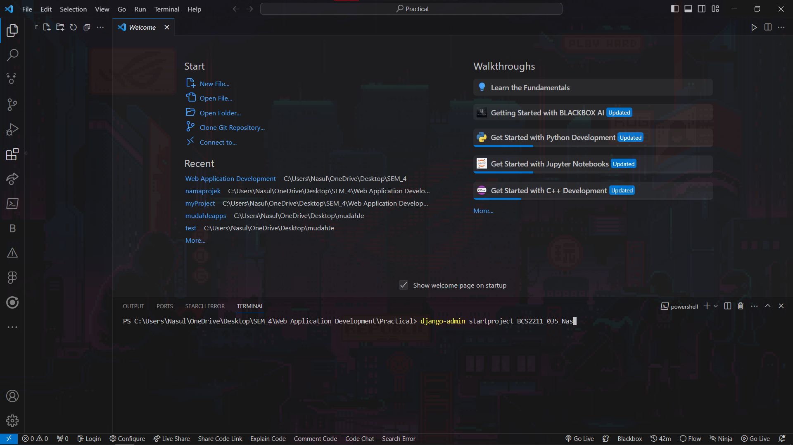

Result:

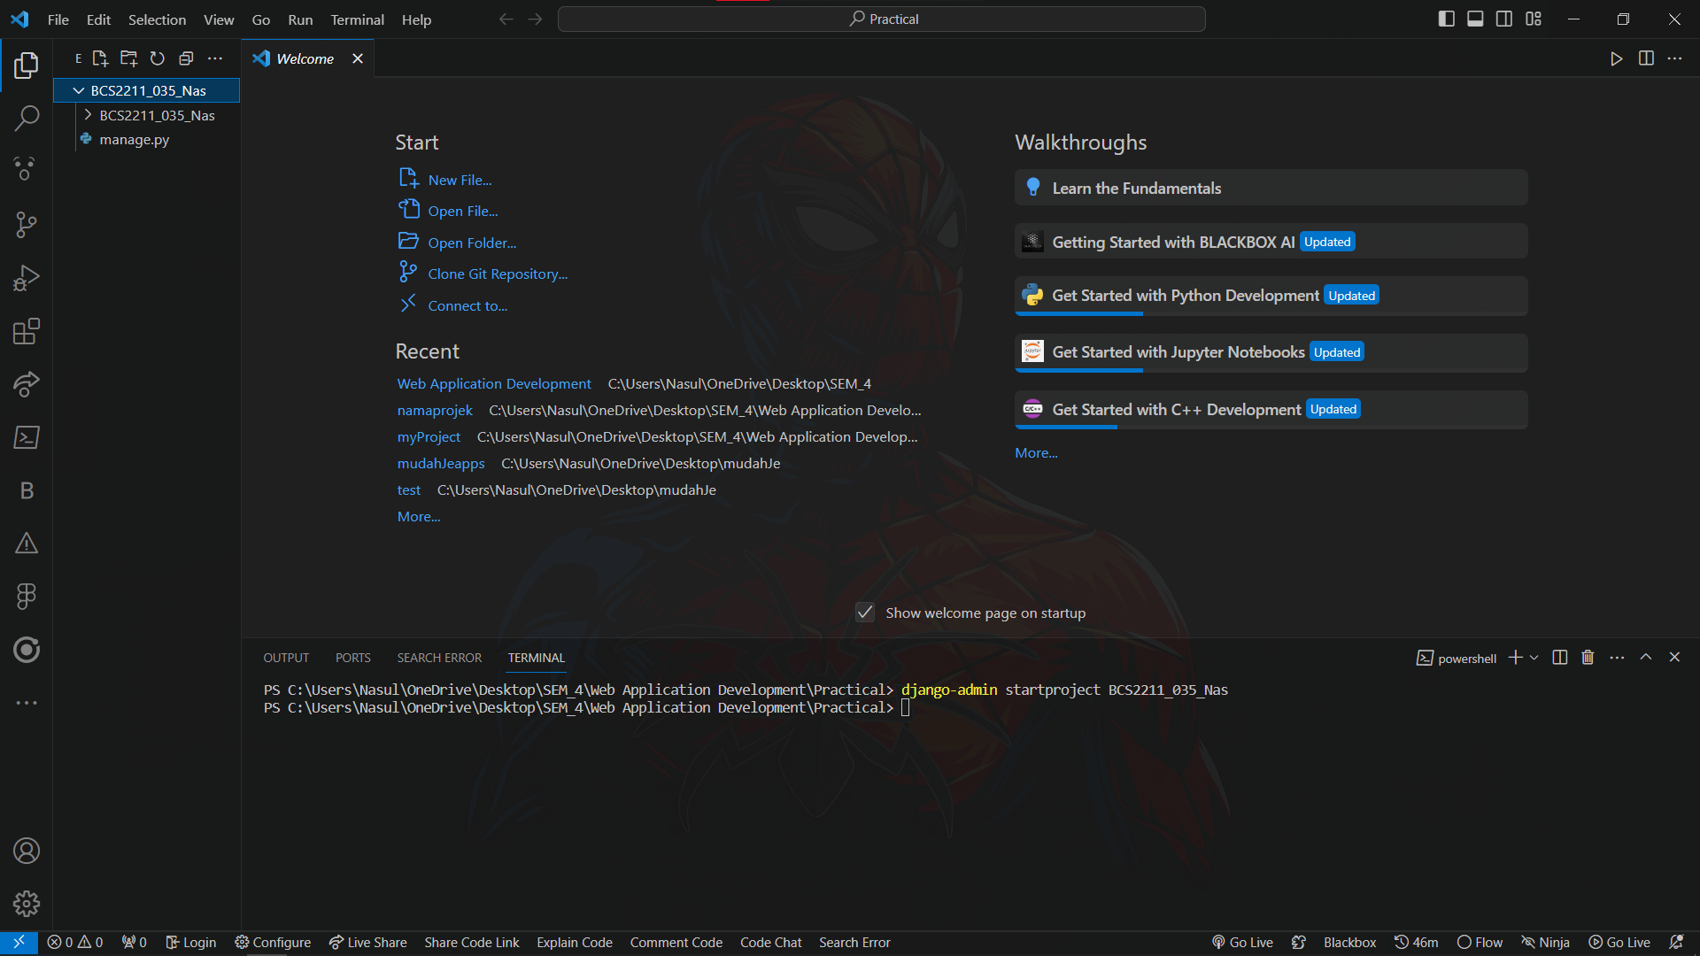

* + 1. Create an application Car

Command:

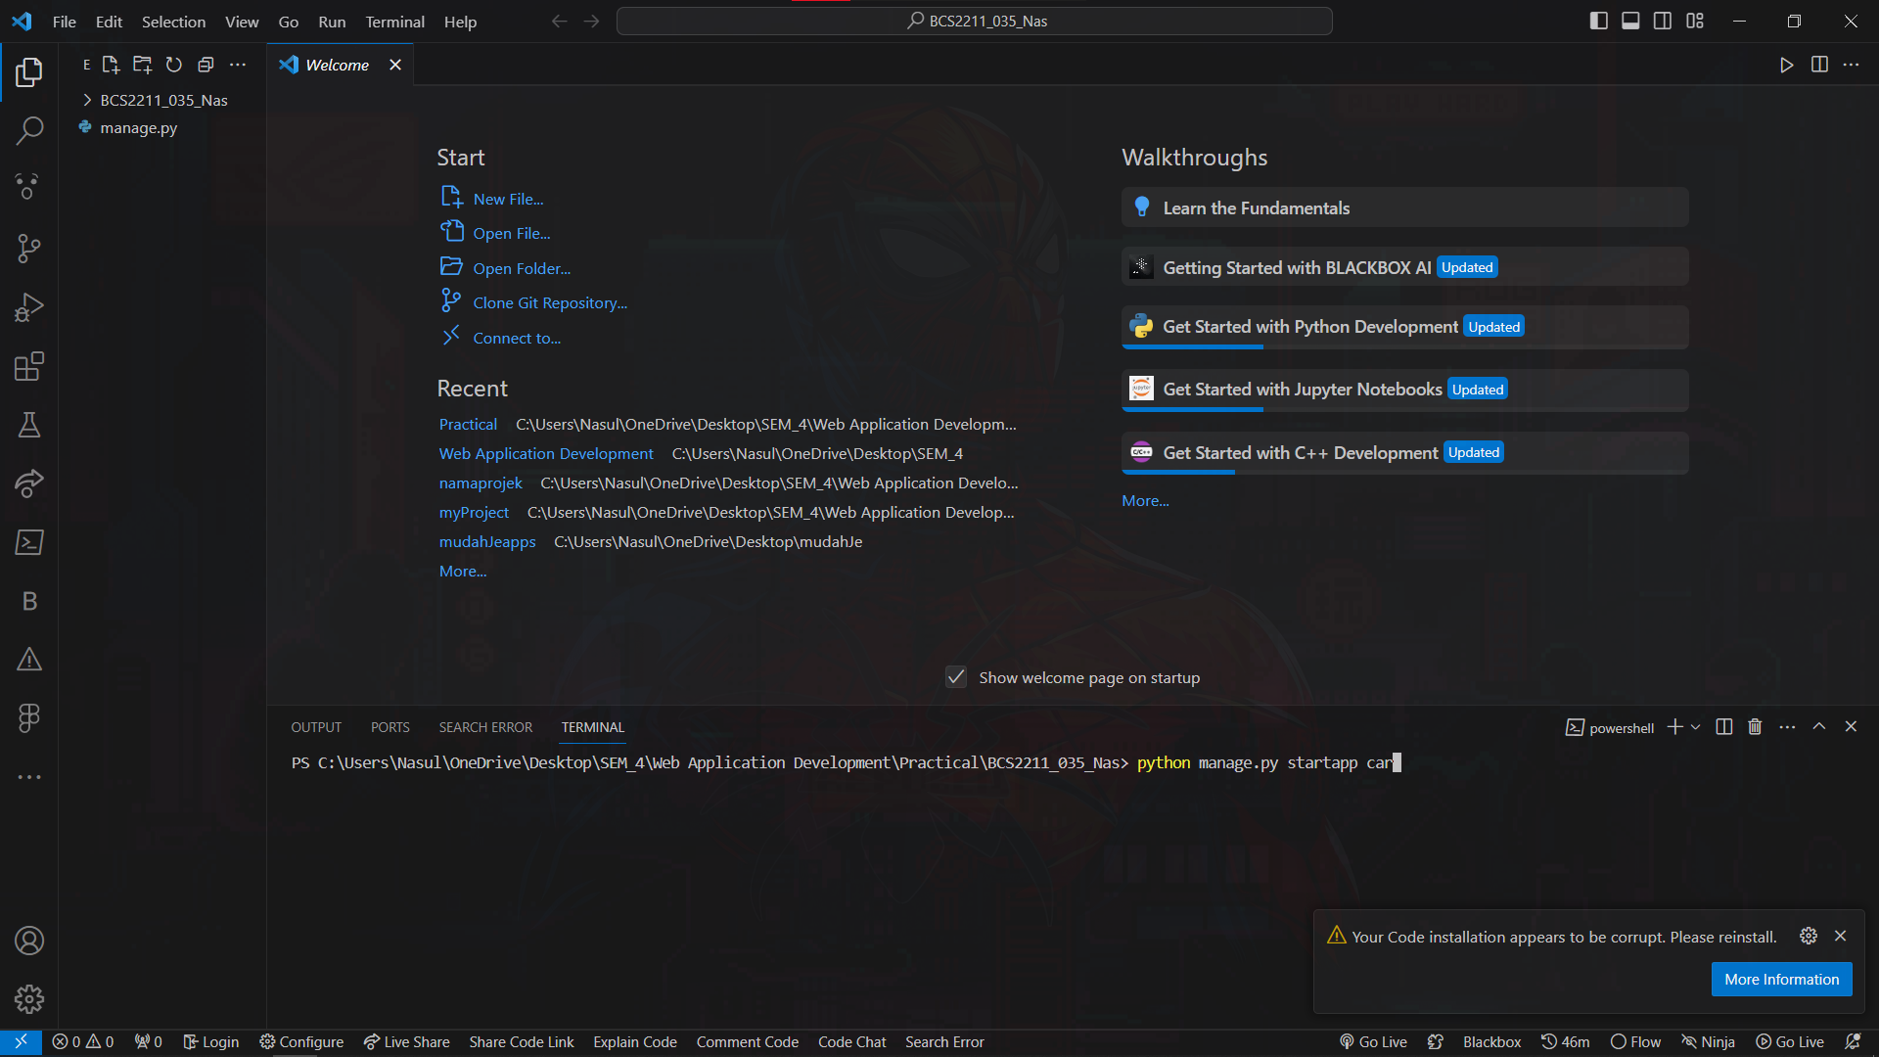

Result:

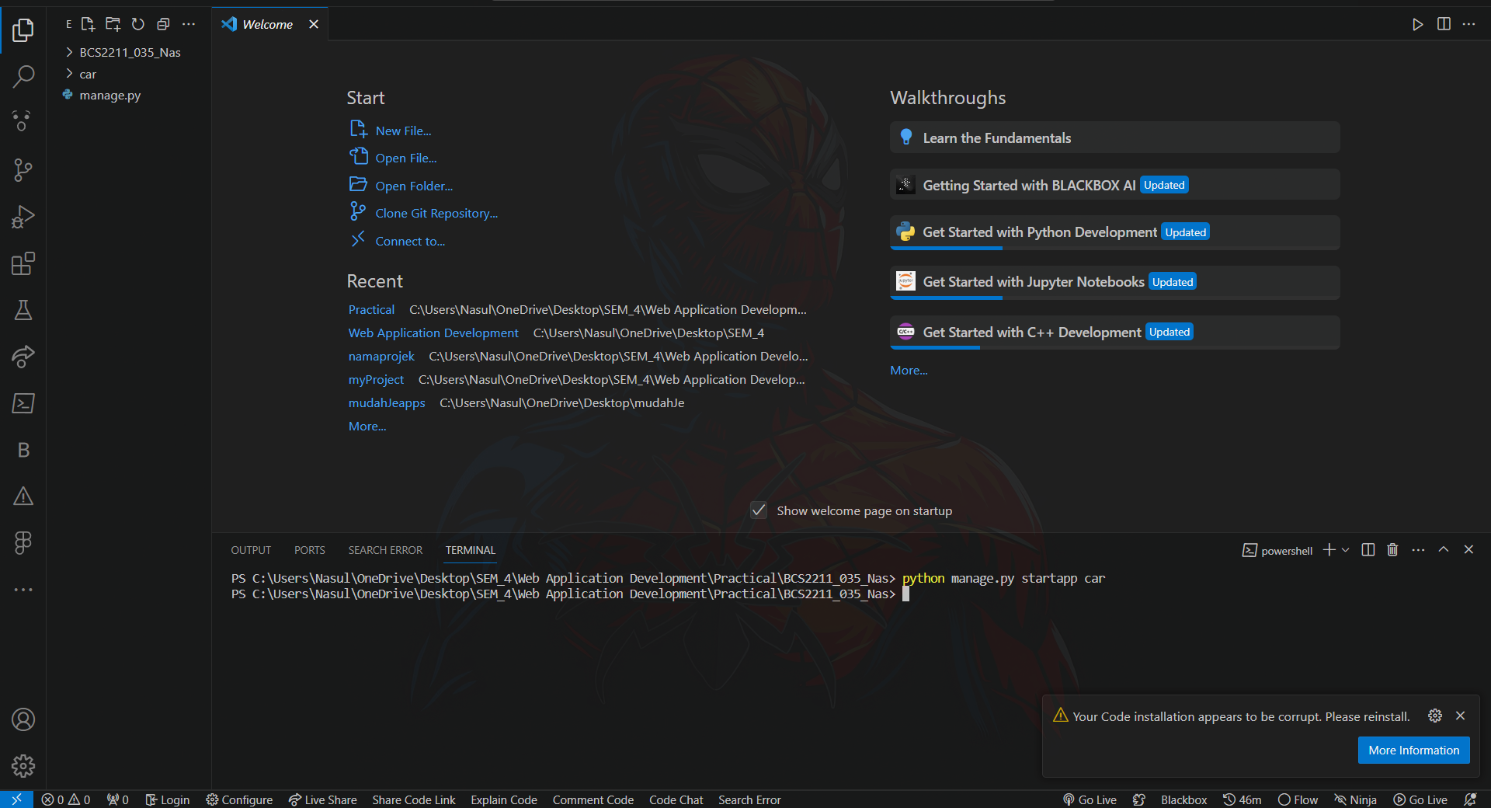

**Part B: Create database using Visual Studio Code. (Task 3-4)**

1. Add application in settings.py

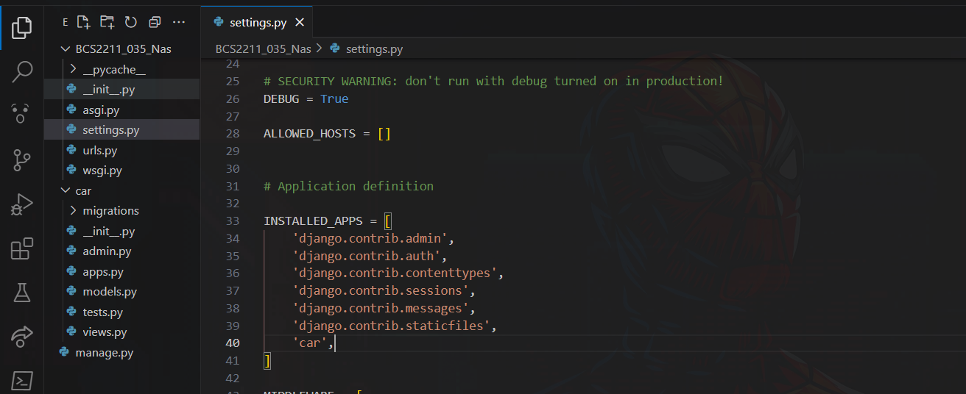

1. Create class based on the tables provided in overview above with appropriate:
2. Class name
3. Properties (data type, maximum number of character)
4. Composition/aggregation

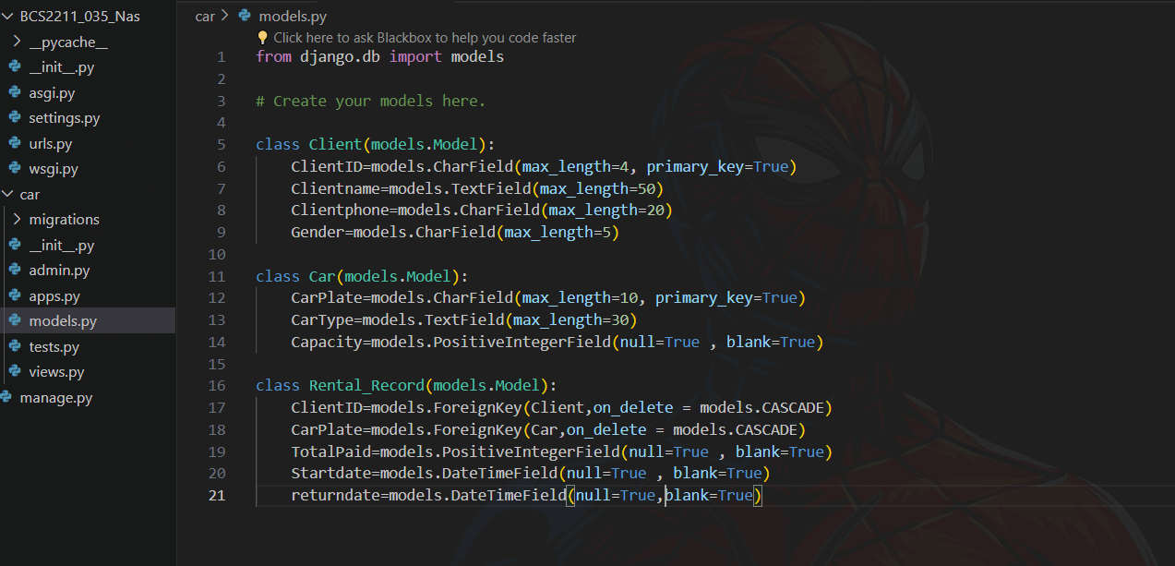

**Part C: Apply database operation (Task 6-13)**

* + 1. Insert all objects into database.
    2. Display objects for all classes using command prompt.
    3. Display all tables and its objects data using Visual Studio Code.
    4. Terminate interactive console by using appropriate command prompt and provide screenshot.
    5. Add new **field CarStatus** in Membership and set default value to **‘Ok’.**
    6. Show updated **objects for CAR.**
    7. Delete object of **CarPlate=QRC5555**.
    8. Display objects in **RENTAL_RECORD** that consists of **CarPlate = JJK3301** using command prompt
    9. Display all objects in all tables after executing all tasks until task 12.